To: | Audit and Governance Committee
Date: | 28 June 2017
Report of: | Head of Business Improvement
Title of Report: | Review of ICT Transformation Project

Summary and recommendations
Purpose of report: |  | To update members on progress with the ICT Transformation Plan
Corporate Priority |  | An Efficient and Effective Council
Policy Framework |  | None
Recommendation(s):That the Audit and Governance Committee resolves to:
1. | Note the report.

Appendices
Appendix 1 | Summary ICT Transformation Plan

Introduction and background
- The Audit and Governance Committee held on 14th December 2016 received a report on progress in delivering the ICT Transformation Plan, following transition to the City Council’s new infrastructure provider SCC. It requested a further update be brought to this meeting. The current summarised version of the plan is included as Appendix 1.
- In the last 6 months a comprehensive transformation plan has been agreed and is in delivery. It focuses on improving the three tenets of infrastructure, people and processes and has included: a wholesale appraisal of ICT infrastructure, both on premise, as well as provided by our Managed Services Providers (MSPs), along with the continuous development of our technical teams and processes, in pursuit of the Information Technology Infrastructure Library (ITIL) standard.
- The plan is updated weekly using an interactive programme management tool (Trello) and monitored by the Chief Technology and Information Manager. Fortnightly progress meetings are held with the Head of Business Improvement and the Executive Director for Organisational Development and Corporate Services. Progress highlights over the last 6 months over the three workstreams are as follows:

People
- Since January 2017, the ICT Operations Team has been organised into smaller, more focussed sub-teams: help-desk, end-user support, networks, telephony and datacentre and core systems. This allows staff to focus and grow their knowledge and become more proficient in specific areas. This has also enabled training to be targeted more appropriately.
- There is now a permanently staffed telephone help-desk with a new Service Desk Team Leader. The knowledge base for the service desk software is continually updated to assist staff with resolving issues. There is now a greater focus on service delivery and closer monitoring of performance, which is reported weekly.
- All operations staff have been assessed against the “Skills Framework for the Information Age” (SFIA), individual training needs have been identified. Development plans have been agreed, and are now monitored and documented through the staff appraisal process.
- We are presently finalising a revised ICT structure to improve operational effectiveness and further embed process improvements into the department. This will ensure consistency of approach, better delivery of service standards and more resilience within the business operation. It is hoped that the consultation will commence in July, and that the restructure will be completed by September.
Infrastructure
- BT One Phone is now operational across the whole organisation with the exception of the contact centre, this will be transferred in phase 2 scheduled for later this financial year. This has enabled office phones and mobiles to be replaced with a single device with all the features of a dedicated local branch telephone system. This together with voice messaging, texts and free intra-business calling functionality, as well as the ability to work outside of the office accessing 4G and over 5 million BT wi-fi hot spots has enabled more effective mobile working, which is essential for the flexible office/home working policies that we enjoy. The Multi-Functional Device printers have been replaced across the organisation resulting in a significant reduction in paper and toner cost, elimination of waste, and improved security through on-demand printing
- In order to address the transformational activities post transition, additional technical resources have been brought in, and these are helping to complete the following by the end of June:
- review of the specifications for the virtual servers that run our applications;
- review of the datacentre network routing and firewall rules;
- re-build and re-deployment of system management software (SCCM) that provides end-user device (mainly laptops) automated build capability, remote control, patch management, software distribution, , network access protection and hardware and software inventory. This was used recently to apply emergency patch updates to council devices to counter the ‘WannaCry’ cyber outbreak; and
- re-design and data-cleanse of the active directory that authenticates and authorizes users and devices in our Windows network, as well as providing application level security and authentication.
- review of current data storage and backup volumes to manage both more effectively. An action plan is currently in progress to better manage volumes of both.

- A replacement Local Area Network switch programme and improvements to site WiFi services is now in progress, following the successful capital bid that was approved in the 17/18 budget process.. We are currently evaluating product options and identifying best-fit vendors with a view to tender.

- The production of an End-User Device strategy, which sets out the design and implementation principles for replacing items including the organisation’s laptops, work stations and tablets, is in progress. An options appraisal is well under way, and a number of solutions are now being considered. These are based around a review of ‘worker-types’ and ensuring we provide the best device for each type of user as determined by their role, location, working habits, and applications used. A number of supplier sessions have been undertaken to consider applicable technologies, affordability, deployment options and supportability. These activities are now approaching completion, and a draft strategy document should be completed by 30th June.

- Improvements to the Council’s Citrix environment are currently being undertaken.
As City Council skills in this area are limited, SCC Professional Services have been engaged and have evaluated our current Citrix environment, and identified the root causes of a number of issues we have identified. The following issues are being addressed,
- User Environments persistence – retaining the logged on user’s desktop and application settings
- Secondary two-factor authentication password issues – second password box displayed
- Netscalar connectivity broker issues with fail-over between devices – availability issue

- Active Directory (AD) is a Windows directory service that enables working with interconnected network resources in a unified manner. The re-design and configuration improvements of AD are substantially completed. Further works to reduce over 200 Group Policy Objects (GPOs) inherited from the Oxfordshire County ICT Services is now completed, and over 150 defunct policies have been removed. Focus has now switched to nearly 4,000 groups, used to divide AD objects (people and devices) into a more manageable number is now in progress, with plans to reduce this number by around 90%. A test connection to MS Azure for Office365 has completed successfully, confirming the AD clean-up work is producing the required outcome.

- Work has started to plan the transition from the datacentre to Microsoft Office365; primary opportunities will be with email and file shares, with email transitioning to Outlook.com, and M-drives and U-drives being migrated to OneDrive. Both these are hosted by Microsoft as part of our Office365 subscription
A project brief for the approach to Member’s ICT has been accepted by the Member’s ICT Group and a Project Initiation Document has been signed off by the One Council Board, which approves and oversees the delivery of projects within the Council. The first phase of this project, a new iPad build for members iPads is approaching completion, and should be going into test phase by mid-June.

Processes
- A real-time communications tool (Slack) has been introduced to the ICT Support teams, which has made collaboration much easier and faster, and is especially useful given staff work out of a number of different locations. Moving to this, and reducing reliance on email for peer communications has made the whole department more responsive and now offers a better co-ordinated service.

An ICT Service Catalogue and Service Level Agreement (SLA) has been produced, and will shortly go to the ICT Steering Group for comment and review. Service definitions and associated performance levels are included, and include agreements to define priority assignment and timescales for handling incidents, service requests, and projects. This work is expected to be finished by the end of June, and will be published to the Council.
Real time, “always-on” dashboards giving real time monitoring for network, datacentre and applications environments have been introduced, and this includes alerting through both email, and the real-time comms tool Slack.
The service desk case management tool (vFire) for logging, analysing and monitoring call handling and resolution has been refined and upgraded, and went live on May 10th with a number of key enhancements. The system now differentiates between an incident and a service request, and also has a category for project requests. The system has a workflow engine now, which is able to route calls automatically to the most appropriate team for triage, a good example of this is an improved “new starter” process which automatically captures all the separate workflow items and directs them to the appropriate resource for action. An automatic escalation facility which will alert staff of cases which are approaching SLA non- compliance has also been introduced. The system also has improved reporting capabilities.
The data shows that we have circa 400 active cases at any point in time, with an additional 300 ‘stopped-clock’ cases on average. Stopped-Clock cases are those where ICT have taken the case as far as currently possible, but are now either awaiting confirmation of closure, needing additional information, or items to be procured or built in order to complete the case.

ICT Work Plan
The 2017/18 ICT Work Plan is being finalised, and for the first time now is being projected over a two year period into 2018/19, rather than just the current year. The remaining 2016/17 items that began in 2016/17 and are set for delivery in 2017/18 have been consolidated into this list and are all on track for delivery as scheduled. Critical ICT development issues for 2017/18 include an Agresso upgrade, the replacement of the Northgate Housing system, Servitor updates, an ICT work stream for the LATCO implementation; and the ICT Transformation Plan itself.

Cyber Security
The City Council’s systems were not affected after the recent cyber-attack. All our systems are regularly patched, and we maintain both an inbound email secure gateway, and regularly updated anti-virus software. Our datacentre is protected by our infrastructure provider SCC, and they regularly patch our systems when updates are released. Antivirus signatures are updated constantly, and our MS product is known to protect against the execution of this vulnerability. We have been monitoring the growth in malicious and spam email activity over the past few months, and are imminently procuring additional software to improve both inbound threat defence, as well as outbreak containment should our defences be breached.

Financial implications
- There are sufficient financial resources within the 2017-18 budgets and within the Medium Term Financial Plan to accommodate the costs of resourcing, training and transitioning the team and for the purchase of software and hardware necessary to complete the 2017/18 work plan.

Legal issues
- There are no legal implications arising from this report

Report author | Helen Bishop
Job title | Head of Business Improvement
Service area or department | Business Improvement
Telephone | 01865 252233
e-mail | hbishop@oxford.gov.uk

Appendix 1
Summary ICT Transformation Plan
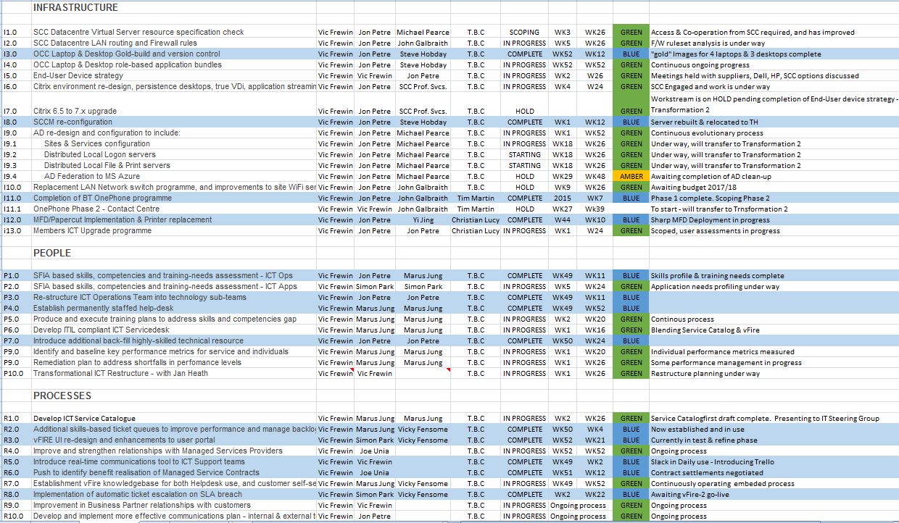
NB Key Dates: week 14 = end March, week 18 = end April, week 22 = end May, week 26= end June, week 52 = end December

